Functional Design

All Rise! Project Topicus x Saxion HBO-ICT

Project members:

* Hassan Babiker ([462644@student.saxion.nl](mailto:462644@student.saxion.nl))
* Bjarne ten Bolscher ([466348@student.saxion.nl](mailto:466348@student.saxion.nl))
* Yang Lin ([450968@student.saxion.nl](mailto:450968@student.saxion.nl))
* Wim Luyendijk ([445662@student.saxion.nl](mailto:445662@student.saxion.nl))
* Ivo Tasev ([469297@student.saxion.nl](mailto:469297@student.saxion.nl))
* Giovanni Tjandra ([445963@student.saxion.nl](mailto:445963@student.saxion.nl))

The contact person for this group is Ivo Tasev – 469297@student.saxion.nl

# **Preface**

As students at Saxion University of Applied Sciences, currently pursuing the software engineering track at HBO-ICT, we were tasked with the course 2.4 project HBO-IT corp. In this course, we were given the opportunity to work on one of Topicus corporation projects. As a client, Topicus asked us to work on a project that could be implemented as a possible solution to problems with sedentary behavior among company employees in their Healthcare sector.

In this document, our group Dev-a3-1 wants to describe the planning side of the documentation on the project. These plans will be further discussed in person with Topicus and hopefully help with the implementation of sprint 1 and the sprint(s) after submission of this document. The purpose of this document is to inform the project owner of our solution to their Healthcare fitness problem and how the project was executed.

# Table of contents

Preface 2

Table of contents 3

Project Background 4

Goal of the Project 4

Requirements 5

Must (Minimum viable product) 5

Should 5

Could 5

Won’t have 5

Use case diagram 6

Wireframes 7

Application Flow 7

Main page 8

Challenge system 11

What is the challenge system? 11

How does it work? 11

Custom challenges 14

Punishments/Rewards 14

Why Fitbit Mobile Track? 15

What can Fitbit do for us exactly? 15

Pros 15

Challenges using Fitbit mobile track (limited) 17

Challenges using Fitbit Device 17

Fitbit Recommendation 18

# **Project Background**

Topicus is an IT company based in Deventer. Topicus works mainly on solutions that serves 3 sectors: finance, education, and healthcare. As a company working mainly on IT, most employees are mostly sitting down during the working period. This created a problem with the employees being sedentary most of the working day. This creates a lot of problem because sedentary behavior will increase the risk of employees having health risks, making them take sick leave more often. Employee’s sick leaves are costing Topicus a lot of money. This is not just happening in Topicus but also other companies as well.

Topicus healthcare believes that early prevention is important in not just preventing a lot of people from needing specialized care but also curbing a lot of preventable costs. Since sedentary behavior exposes people to a lot of health risks in the future, preventing sedentary behavior will help with preventing future health issues.

Topicus healthcare would like to have a solution to prevent sedentary behavior in the workplace of companies especially Topicus. This solution should promote behavioral changes in employees. Either by introducing changes to the social environment of the office, or competition to reward the employees that follows the changes in activity, as well as to educate them on how important not being sedentary really is. This solution will be presented as a product that can be accessed by the employees in the office and should be secure and scalable.

# **Goal of the Project**

The goal of the project is mainly to solve the problem of sedentary behavior in the Topicus office environment. As a permanent solution, it should be able to encourage employees to reduce their sitting time. This is done by introducing different activities that promote social changes, competitiveness, and information. This solution should be able to decrease the sitting time of the employees that usually work most of the day sitting in the office. It will allow the employees to not just be active during work hours, but also help maintain higher levels of focus with their work.

# **Requirements**

## 

### Must (Minimum viable product)

* + Users must be able to track their calories.
  + Users must be able to see their progress on how many calories they burned.
  + Users must be able to challenge each other to a specific activity.
  + Users must be able to see how well they do against others by means of a leaderboard.
  + Web Application must be able to scale between mobile and desktop sizes.
  + Web Application must be secure.

### Should

* + Users should get a daily overview of their performance
  + Users should be able to set a personal daily goal on how many calories to burn.
  + Users should join a team/company and represent them in challenges
  + Users should get health tips when they open the app for the first time in the day.

### Could

* + Users could be able to see their avatar
  + Users could be rewarded points based on their activity
  + Users could be able to customize their avatars using said points

### Won’t have

* + Users won’t collect badges from NFC devices
  + Users won’t collect badges
  + Users won’t be able to cash in rewards for collected sets of badges
  + Users won’t be able to trade badges with each other

# **Use case diagram**

## **Fitbit and Security**

For our application we will be using Fitbit, which allows us to gain access to information from our phones sensors without having to manually code it ourselves. Fitbit will also allow us to login into the web page. Using Fitbit OAuth lets us manage employees inside our database without having to create a secure log in to protect the employee's data. Having these technologies allows us to get a strong base for the application right from the beginning, giving us more time to develop useful features.

Fitbit provides the possibility for developers to integrate the use of Fitbit products into their own systems, through the Fitbit API. This allows us to easily implement features using the provided data from the app. The Fitbit API is free to use, which makes it ideal for a project.

## **What can Fitbit do for us exactly?**

We can get data such assteps, distance, and calories burned. In addition to activity tracking, you also have access to other app features such as:

* Food tracking
* Weight tracking
* Setting fitness goals
* Adding friends
* Friends leaderboard
* Cheering, taunting, and messaging friends

The data we will be focusing on is the **calories,** by transforming those calories into points we can then introduce a simple way of measurement for our competition and to make things more enjoyable by the user.

# **Wireframes**

These wireframes are our take on how the application should look and feel overall. These will be the guide for the team work on frontend implementation. After the app is fully realized, the web app should look like the ones we are going to present further. We have included the wireframes for mobile as well as desk top displays.

## **Application Flow**

The diagram below will illustrate how the flow of the application will generally look like. This shows how one screen changes to another to perform a functionality that is designed to be in the minimum app.

## **Main page**

The user will sign in through a Fitbit OAuth, and then will be taken here. On this page the user will be able to see an overview of their daily progress. As well as their accumulated points, steps, calories burned and challenge coupons that they have collected.

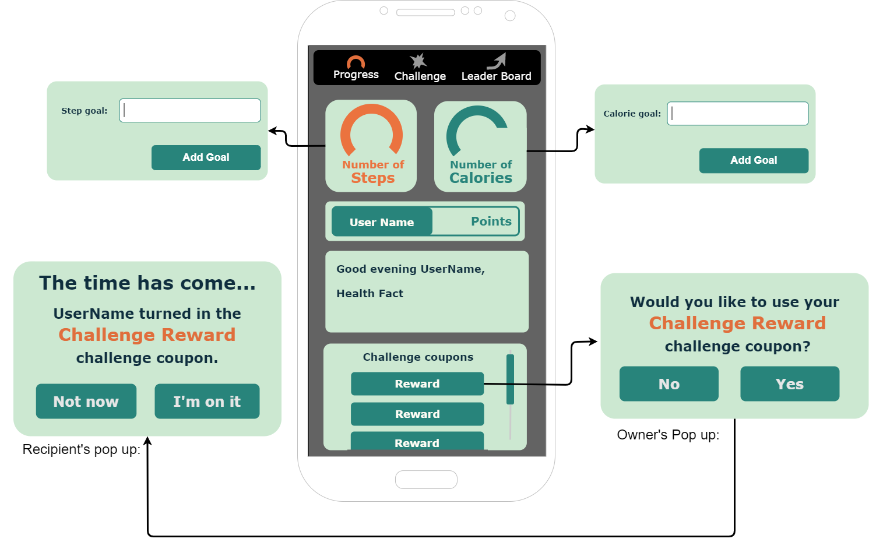

The circular loading bars will show the user their personal progress towards a specific goal. These goal bars are reset between every workday. By default, both bars will be the dark green color. Upon reaching the goal for the category the bar will turn orange, signifying that the goal has been met. By setting attainable goals the user will have more incentive to reduce sedentary behavior. These Progress wheels allow the user to be able see how close they are to attaining their daily goal and seeing how many steps or calories they have burned. This satisfies our Must Requirement for users being able to see their progress on the calories they have burned.

Below the progress wheels there is a points card that displays the employee’s accumulated points. These points can be gained through being more active during the workday. We will calculate an appropriate amount of points per day based on the user's activity on the application combined with the data pulled from the Fitbit API. The Points section is related to where an employee stands on the leader board, which is discussed in the Leader Board section of this documentation.

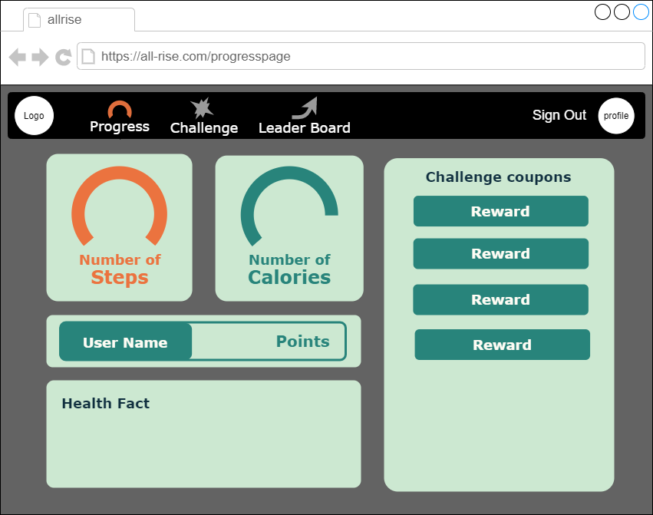

The next card down is a greeting card. This is how the system will send messages to the employee. System messages will greet the user and can give them positive reinforcement by congratulating them on reaching a goal. The greeting card will also give the user interesting health-based facts. These facts will range from facts about reducing sedentary behavior to health tips that can help the user become more productive during the day. This card gives an educational aspect to the Web Application by giving the user health tips. An idea to expand this concept would be to incorporate targeted health tips. This could be done by pulling health tips that relate to the time of day or activities that the user is participating in.

Finally, the employee’s challenge coupons are displayed. These coupons are a representation of agreements between two employees. Acting as a prize for the challenge. Before a challenge begins the users will agree on what the reward will be. After the challenge, when they agree on the winner the coupon will be sent to the winner. The owner of the coupon can redeem it at any time, so if both parties are busy after the challenge it can be used at a later date. When the owner wants to redeem their coupon, they can select it and confirm that they want to use it. The loser of the challenge will be given a message that the coupon has been used. They then can accept the message and do what was agreed upon. However, sometimes it is not possible to do the favor at that moment. So, the recipient will also be able to deny the request. This will close the notification and reopen the next time they open the progress page. The notification will continue to open for as long as the coupon is activated. The owner can retain the coupon by deactivating it, this will stop the notification on the other user’s progress page. In our final product there is no penalty for postponing a coupon. However, it may be a good idea to add a penalty for postponing a coupon too many times to make sure that employees fulfill their obligations.

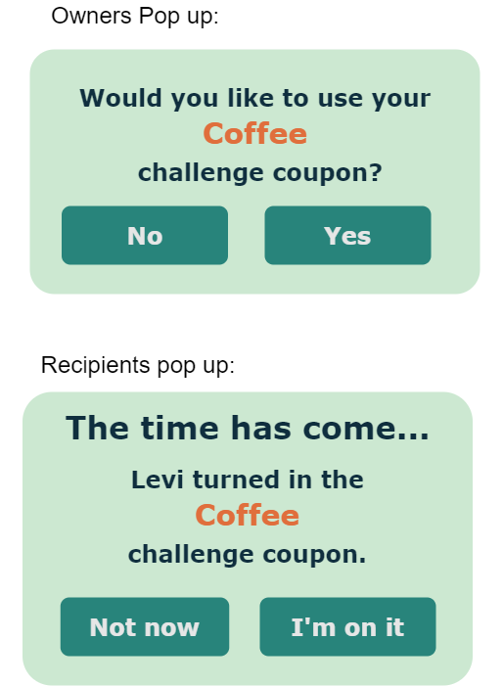

### Setting Daily goals

By clicking on one of the progress wheel containers, a pop up will display that allows the user to set their daily goal for steps or the number of calories that they want to burn. This fulfills our requirement for allowing users to set their daily goals.

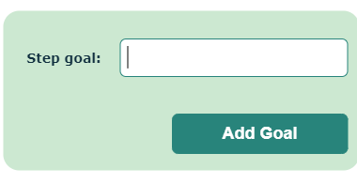

**Leaderboard**

This page of the application is to get the employees more enthusiastic about attaining their health goals. By giving them a platform to see how well they’re doing compared to their colleges as well as the bragging rights to making it to the top, we hope to spark some friendly competition. Apart from the top positions, there is also a proximity list. These are the employees that are closest to the user. This will help encourage employees to be more active, by setting smaller more attainable goals than making it to the very top a user can overtake a few people at a time.

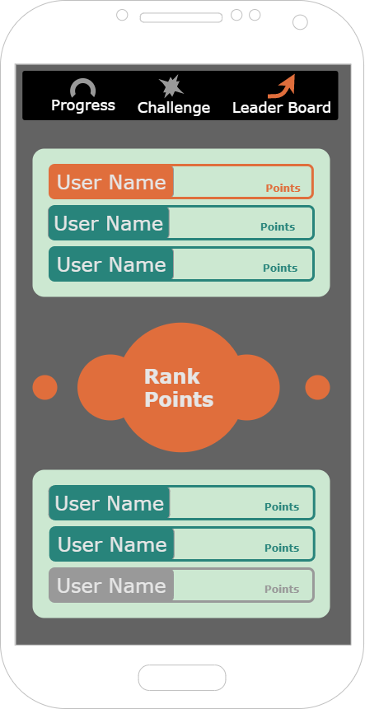

Since the number of participating employee’s is unknown it may not be possible to display all of the users on the leaderboard. To let the user know where they are on the leaderboard. The middle component displays their rank and the amount of points they have. The color of the icon will help symbolize their position. Most of the time it will be dark green while they are in the middle of the pack. When the user reaches a place on the leaderboard their position indicator will become orange. However, if they fall into last place their indicator will turn grey, letting them know that they should be a bit more active. An example of the different colors of the Position Indicator can be seen in the wireframe below.

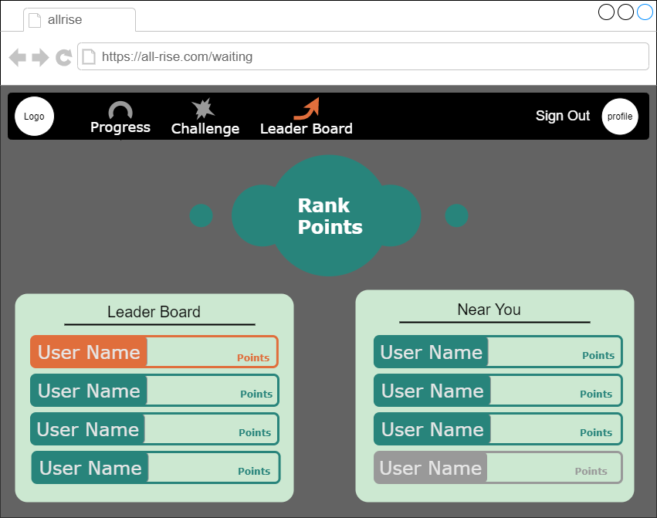

## **Challenge system**

The challenge system adds a friendly competitive aspect to the application. The way this will work is with 2 types of challenges either fixed or custom. When you click on the button for the challenges page you select which mode you want to play and what challenge. If you pick a custom challenge you would have to fill in everything by yourself.

When creating a challenge, the user would be taken to a challenge form where they can fill in the details to challenge a co-worker. In the reward bar, they can specify what the winner will receive for winning the challenge. Of course, the person being challenge has the right to accept or decline the challenge. After the challenge is over, the reward will be given to the agreed upon winner.

The navigation of the challenge system will first start a waiting room for pending challenges. If you click the play button you will start the challenge, and if you click the plus button you will be taken to the right. Where you can pick from a list preset challenge or create your own custom challenge. This gives freedom to the employees to introduce creativity to their challenges. In our final product Free Challenges will only give the winner of the challenge a reward. A nice feature to expand Free Challenges further would be a query using the Fit Bit API which can give calories burned for doing an activity if it exists in the Fit Bit activity list. This would reward the employees for participating in a challenge and enrich the Free Challenge experience.

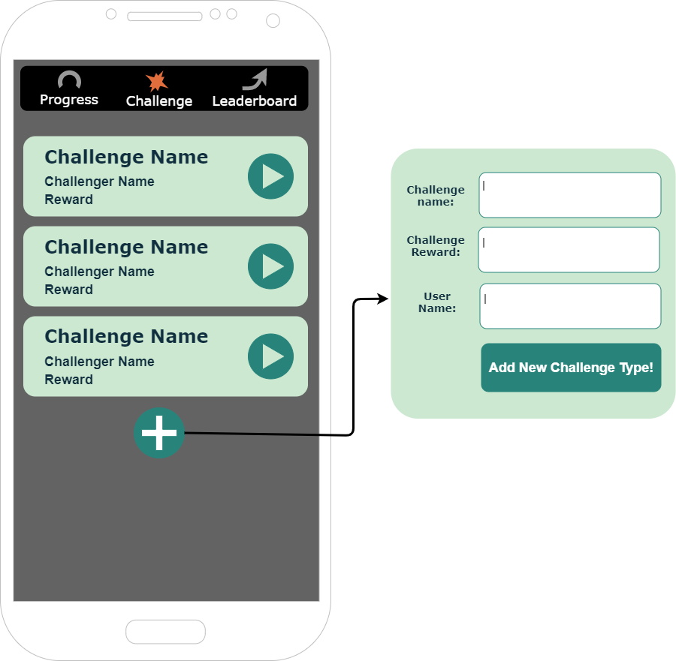

Creating a new challenge pop up will allow you to specify a challenge with a description. Once you have created your custom challenge, or have selected a preset one, you will be taken back to the challenge waiting room where you can begin the challenge with the employee you challenged.

While in a challenge there is an orange circle that acts as the start button. By pressing the cirlce the timer and challenge will begin. The timer allows the employees to see how long the challenge has lasted and helps determine how many calories they will earn if it is a fixed challenge. To finish the challenge, you click the finish game button and are then taken to the right screen where you and your partner will declare a winner. In order to receive the agreed upon reward, both users must agree on a winner. If they select a different winner from each other then they will be asked again. If a winner can’t be agreed upon within three tries neither party will receive the reward.

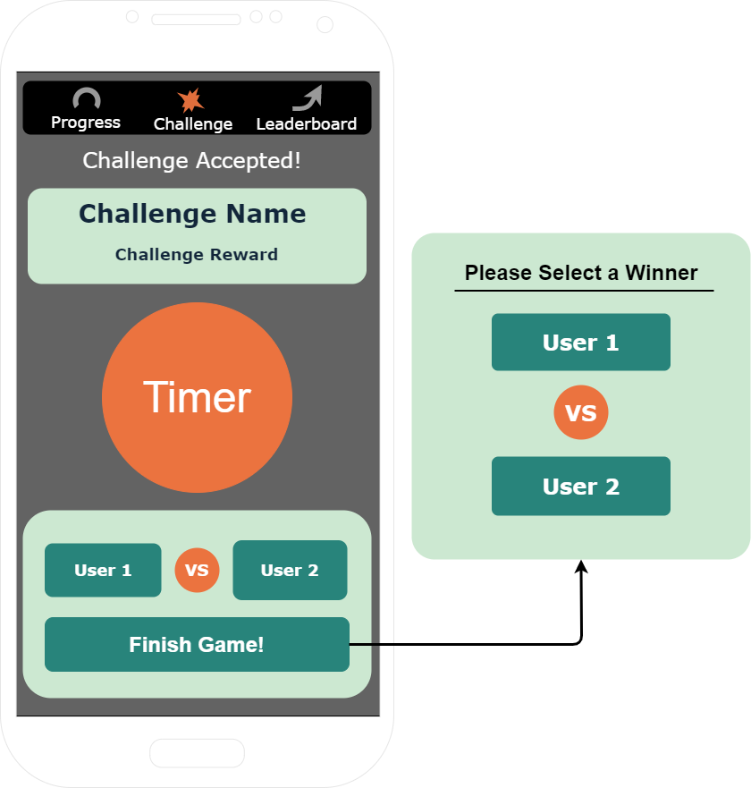

Fixed challenges

The way the fixed challenges are decided are based on the data we can track from the Fitbit API. These are challenges such as

1. Most calories burned
2. Most floors climbed
3. Most distance covered
4. Most steps done

From these challenges the application can determine who the winner is by the end of the challenge by comparing the user's data. Free Challenges on the other hand must have an agreed upon winner before the reward can be given.

For the custom challenges you decide on the name, participants and Punishment/Reward. These challenges do not need to be able to be tracked by the Fitbit API and can be anything a few examples would be

1. A game of foosball
2. A game of ping pong
3. Fastest to do 10 push ups
4. An arm wrestling match
5. Rock-Paper-Scissors

### **Punishments/Rewards**

The Punishments/Rewards are small stuff that are not a huge inconvenience for the other but more like a quality of life for the winner. For examples we came up with a few Punishments and Rewards:

1. Get me a cup of coffee.
2. Bring me an apple.
3. Print a document from the second floor.
4. Wear a silly tie tomorrow.

These rewards or punishments are only really limited to the creativity of the employees as long as they aren't too overly distracting.

### Pros

* Free to use
* Works with most devices (Android 7, Apple iOS 12+)
* Provides Integrations for developers

Cons

* Not as accurate as Fitbit device.
* Can only get daily estimate of burned calories
* No heart rate tracking

### **Challenges using Fitbit mobile track (limited)**

The calories number you see on your Fitbit is your estimated total calories burned for the day not from specific exercises, activities , by transforming those to points colleges can compete on who gets the most on their day of work and the winner is King. . currently we are limited to this in addition to the step's calculation.

In order to fully utilize it on specific challenges we would need to use a Fitbit device that can track heart rate only then we can get data from certain activity.

### **Suggested Challenges with the Fitbit device**

**Overall Leaderboard**

This is not a specific challenge but the same leaderboard but it's with a more accurate simple more detailed and accurate data leaderboard where you can see who has, the most steps, the most burned calories.

**Burner**

1 vs 1 challenge, each is free to do whatever they want. The end goal is who burns the most calories in a specific time period.

**Max Volume**

If you want to push it a bit further you should go for this, you are free to do whatever you like. The end goal here is to get your heart rate up, the highest one wins (not suited for weak hearts).

**Climber**

Challenge your friends who gets the most floors count, your Fitbit device only counts your way up.

**Fitbit Recommendation**

**Fitbit Charge 4**

Screen: Yes | Heart rate tracker: Yes | Waterproof: Yes | Activity tracking: Yes |GPS: Yes | Battery life: Up to 7 days | Compatibility: Android/iOS/Windows

**Fitbit Charge 3**

Screen: Yes | Heart rate tracker: Yes | Waterproof: Yes | Activity tracking: Yes | GPS: Yes, through phone | Battery life: 4/5 days | Compatibility: Android/iOS/Windows